ST. ANDREWS INSTITUE OF TECHNOLOGY AND MANAGEMENT

NAME – ARZOO

ROLL NO – 229194

COURSE- BCA

SECTION – B

PROJECT – TECH HUB STUDY

LANGUAGE USED HTML AND CSS

INDEX

* About project
* Navigation bar
* Html and CSS used in website
* Output we get
* ACKNOWLEDGEMENT
* CERTIFICATE

Acknowledgement

I would like to special thanks to “garvit sir” for their able guidance and support in completing my project.

I would also like to extend my gratitude to HOD MAM MRS. ANKITA for providing me with all facility that was required.

DATE: ARZOO

2/12/2022 BCA SEC ‘B’

CERTIFICATE

This is to certify that ‘ARZOO’ student of BCA department has successfully completed their project on “HTML AND CSS” language under the guidance of Mr. Garvit sir.

PROJECT BASED ON TECH HUB STUDY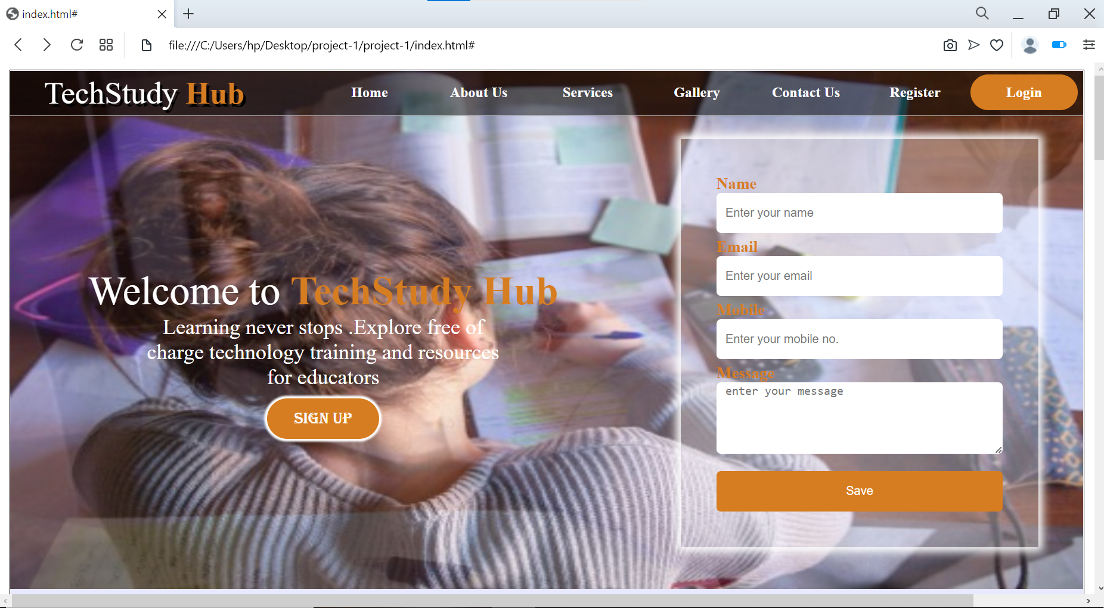

NAVIGATION

**FORM**

Z

INPUT

OUTPUT

**OUR SERVICES**

ABOUT US

**THANK**

**YOU**